**Deposit JayBuck$ through eAccounts**

1. Go to <http://cardservices.creighton.edu>  
   (it will reroute you to ([http://www.creighton.edu/admin/cardservices/cardservices/) 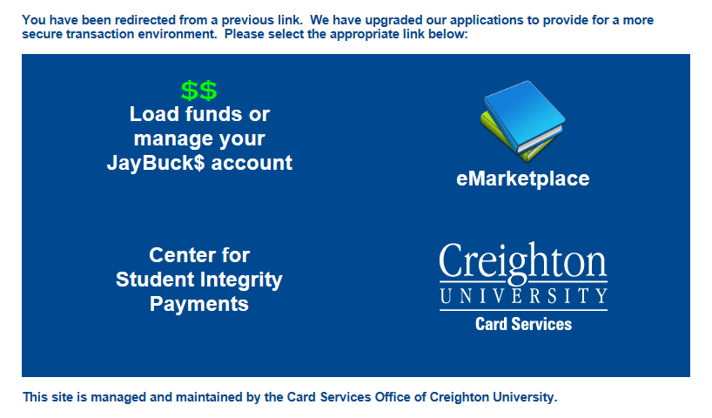](http://www.creighton.edu/admin/cardservices/cardservices/)%20%20)
2. Click on the **$$ Load funds or manage your JayBuck$ account**.

**Option 1:**

1. Click the **Sign In** button.
2. Enter your **NetID** and **Blue password**.
3. Under the JayBuck$ area click **+Add Money**.

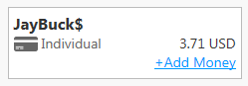

1. You will need to select a **Deposit Type**, **Deposit Amount**, and the **Payment Method**.
2. Click the **Next** button.
3. Enter your VISA or MasterCard information.

**Option 2:**  (If problems are encountered)

Note: Because some systems are locked down and restricted users cannot agree to some settings when signing into their account.

1. Users may have to click on **Make a Guest Deposit** button.
2. Enter the required information.

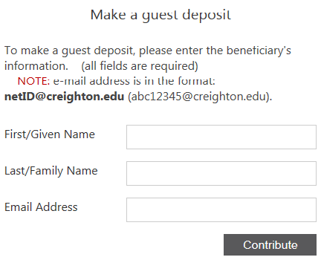

1. Click the **Contribute** button.
2. Enter a deposit amount (minimum deposit is $10.00, maximum deposit is $9,999.00).
3. Click the **Next** button.
4. Enter your VISA or MasterCard information.